Friends and Family Data–January-2025
Summary of Patient Comments
- “Very happy with the nurse and the service overall”
- “Responsive, thorough and helpful”
- “Efficient and was really friendly”
Total Responses | 150
Very Good | 111 | 74%
Good | 33 | 22%
Neither good nor poor | 3 | 2%
Poor | 1 | 1%
Very Poor | 2 | 1%
Don’t know | 0 | 0%

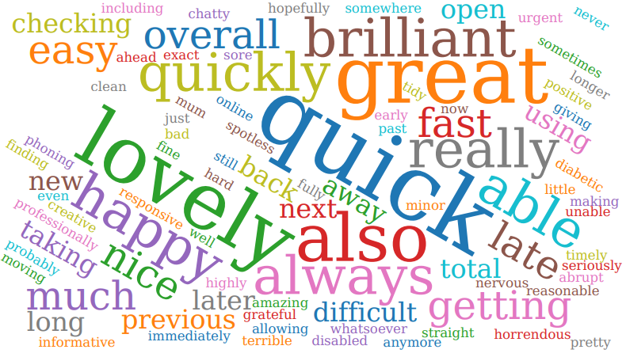

Examples of Comments
- “I was seen ahead of time and staff listened to my experience of years of venepuncture and were able to cannulate at first attempt. In my view they were both professional and efficient”
- “Surgery returned my call, appointment made today, and GP self-referred me to hospital which I have completed. Appointment also made for bloods etc. A professional service from all.”
- “Staff Work so hard and professionally under very difficult circumstances I just wish surgery pharmacist, and hospital could work out a more joined up enhanced service with further government investment via creative efficiency ideas from the people on the front-line care. Probably allowing another line of help via pharmacist centre for minor illness? NHS staff should be better recognised, respected and rewarded more for their total patient dedication and care .... the sooner the better!”
- “I got an appointment which was needed. I got antibiotics by 2:20 also needed but never see a doctor anymore so little continuity of care, no relationships built with practitioners and multiple steps which would be impossible to manage at work.”
- “Asked for GP appointment and was offered a telephone appointment 11 days later. Or advised to make an online request but this route is only open first thing after the telephone lines open before capacity is reached. Also, don't seem to be able to get an appointment at Freshfield surgery nearer where I live and easier to park.”

The Formby Village Surgery Feedback-
The Freshfield Surgery is mainly reserved for our acute appointments, but we try and accommodate to all patients needs.
We understand the parking at the Village Surgery is an issue at this current time and we are working towards a suitable fix for all our patients and staff.

