Friends and Family Data–September-2025
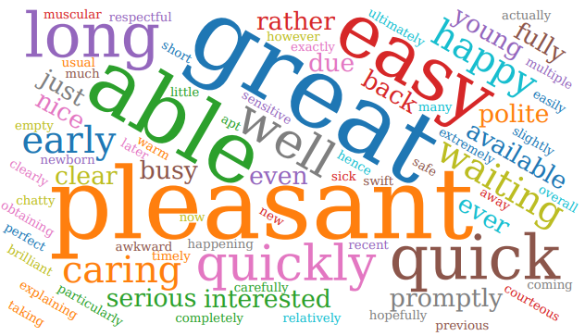
Summary of Patient Comments
- “Pleasant on time took me serious”
- “It was a quick and good service”
- “All staff were efficient and attentive”
- “Quick Professional taking of my blood”
Total Responses | 147
Very Good | 126 | 86%
Good | 16 | 11%
Neither good nor poor | 2 | 1%
Poor | 2 | 1%
Very Poor | 1 | 1%
Don’t know | 0 | 0%
Examples of Comments
- “I was able to see a doctor same day and was very helpful plus reception staff were great even though the practice was very busy and the computer had to be reset due to a problem”
- “I gave an "excellent" rating as the reception, nursing and pharmacy staff have been helpful and friendly”
- “I always get an appointment when I need it. Good service from the doctors and nurses at the appointments. I find the staff friendly and always helpful. Thank you”
- “Was able to book an appointment relatively easily although it would be good to be able to use the NHS/GP App to book. Didn't have to wait long when I arrived for the appointment. Had to ask about what to expect rather than have things explained, but achieved what was needed.”
- “No car parking spaces ever available, particularly for baby. No room available for unvaccinated child to await vaccines having to be in waiting room with dozens of sick people. Too long waiting to see GP - over 30 minutes with a newborn baby.”

The Formby Village Surgery Feedback-
Under the new NHS legislation, we have implemented the new Digital Front Door system, that will enable patients to be able to submit any request anytime during opening hours for the Doctor to triage that same day. Once Triaged by the Doctor the patient will either be sent a text message that includes all the available appointment times or be contacted by our reception time over the phone if unable to book via the text message.

