Friends and Family Data–August-2025
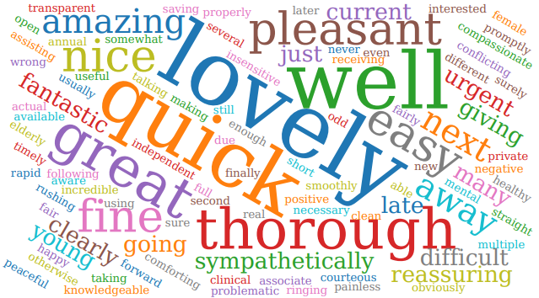
Summary of Patient Comments
- “Easy check in, on time, lovely practitioners”
- “The staff on telephone were very helpful & friendly”
- “Nurse was friendly & professional”
- “Seen on time, efficient service”
Total Responses | 149
Very Good | 124 | 83%
Good | 12 | 8%
Neither good nor poor | 6 | 4%
Poor | 4 | 3%
Very Poor | 3 | 2%
Don’t know | 0 | 0%
Examples of Comments
- “I was worried I may not have enough time as it was my first visit to a UK GP in 40 years but all went smoothly”
- “Just efficient. Person at reception smiled and polite and my appointment was on time”
- “Good systems in place for efficient allocation of Medical staff to Patients in a reasonably timely manner. Cost effective, fair and responsive to Patients needs. Excellent Reception and triage staff, polite, welcoming, patient and helpful. All Doctors, Physician Associates and Nurses in my experience have given excellent responses to Patients needs. I think everyone is doing a very good job , they smile and are welcoming and helpful. Thank you for Practise Leadership which achieves this”
- “The appointment was 20 minutes late. It took an age to see try and arrange an appointment with the practice nurse for an annual blood pressure check and blood test, but still not resolved. Plus side? The waiting room was a peaceful haven for reading.”
- “Doctor was very good and professional and patient.The appointment system needs a bit of an overhaul as difficult to obtain a non urgent appointment. Surely there must be a better way than ringing on the day and using up an urgent slot.”
- “I felt that after waiting 30 minutes to see the doctor, the doctor rushed me and I came away feeling I wasn’t properly listened too.”

The Formby Village Surgery Feedback-
Under the new NHS legislation, we are working towards implementing a new online system that will enable patients to be able to submit any request anytime during opening hours for the Doctor to triage that same day. This will also aim to prevent the need of calling at 8am to ensure a same day appointment.

