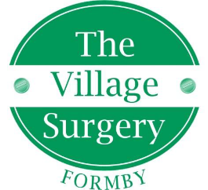

SERVICE IMPROVEMENT MANAGER (DEPTUTY PRACTICE MANAGER)

Full time (part time will be considered)

Salary dependant on experience

An exciting opportunity has arisen for a new role within the Village Surgery Formby.

We are looking for a Service Improvement Manager (Deputy Practice Manager) to play a crucial role in driving continuous improvement within the Village Surgery. The pace of change in the NHS is unceasing and we require a person with strong project management and organisational skills to work with both clinical and non-clinical practice staff to drive us forward with all of the required changes as well as supporting the development and embedding of a continuous service improvement culture with practice staff and improving efficiency. This role will be key to ensuring that we consistently deliver a high-quality service for our patients.

Enquiries and applications (by C.V) to [susan.lowe9@nhs.net](mailto:susan.lowe9@nhs.net)

Closing date: 14th February 2025

Interviews the week commencing 17th February 2025