Friends and Family Data– April-2025
Summary of Patient Comments
- “Seen punctually. Efficient Staff”
- “Patient and good manner”
- “Responding quickly and efficiently”
- “My diabetic nurse is the best”
- “The PA I saw was absolutely brilliant”
Total Responses | 149
Very Good | 116 | 78%
Good | 21 | 14%
Neither good nor poor | 7 | 5%
Poor | 2 | 1%
Very Poor | 3 | 2%
Don’t know | 0 | 0%

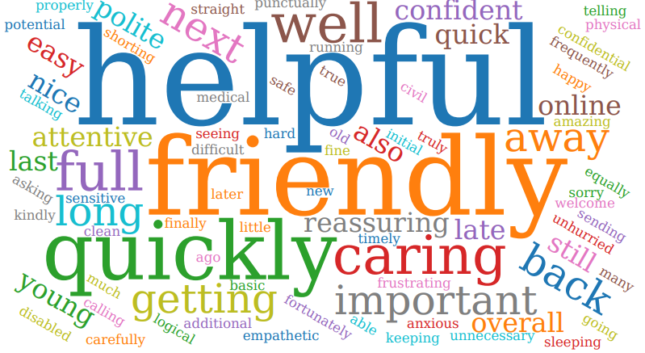
Examples of Comments
- “Appointment made same day when requested and Dr didn't rush gave full examination. Receptionist where very kind as have hearing problem”
- “The doctor was great with my young son, made us feel welcome, and also confident with his diagnosis”
- “Although I waited a while for a telephone appointment the doctor who explained my blood results was thorough & clear & quickly arranged a further blood test which was carried out within a few days & also other additional tests. Overall, the process was timeous & efficient.”
- “Called to book appt at 8:05am for my husband and 10month old. 30+ people in the queue, requested the call back. Called at 10 to check number of callers,”
- “Call back service doesn't work takes over an hour to get through to them over the phone”

The Formby Village Surgery Feedback-
We are currently working with our phone provider to improve the phone queues and help guide the patient flow towards the appropriate department.
We are also working on providing more information to patients about the appropriate alternative points of contact that can help reduce the amount of calls we face in a day.

