Friends and Family Data–February-2025
Summary of Patient Comments
- “Very thorough and helpful. Made me feel at ease.”
- “The service my wife and I receive is first-class.”
- “Good service and efficient”
Total Responses | 150
Very Good | 105 | 70%
Good | 32 | 21%
Neither good nor poor | 4 | 3%
Poor | 1 | 1%
Very Poor | 7 | 5%
Don’t know | 1 | 1%

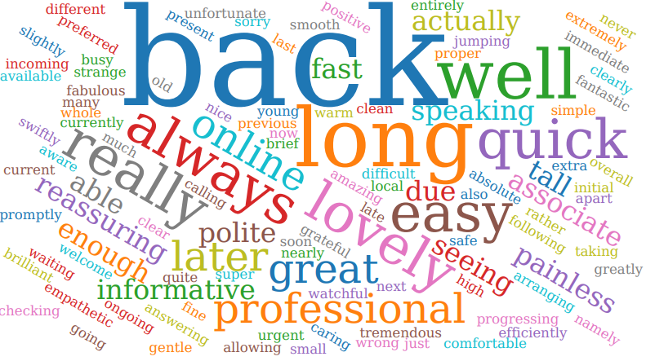

Examples of Comments
- “Shown respect both by the GP, receptionist and later by two members of staff at the other Formby surgery”
- “I was given an appointment quickly and then seen swiftly allowing me to feel reassured. The staff explained what was wrong and what was needed to help
- me get better. I felt very reassured”
- “Although I waited a while for a telephone appointment the doctor who explained my blood results was thorough & clear & quickly arranged a further blood test which was carried out within a few days & also other additional tests. Overall, the process was timeous & efficient.”
- “I used the self-service booking, so had I need to go to the reception. I was seen by the doctor on time and was very satisfied with my consultation”
- “On hold for 2 hours then disconnected and told to call back later Called back to be put at back in queue”

The Formby Village Surgery Feedback-
We are currently working with our phone provider to improve the phone queues and help guide the patient flow towards the appropriate department. This is an ongoing process that we are continuously working towards improving and we fully understand the frustration.

